

Synopsis Report for

“Portfolio Website”

**Submitted By:**

1. Suraj Kumar Sharma 2003610100057
2. Pankaj Singh 2003610100037
3. Indresh Kumar Verma 2003610100027
4. Shivam Srivastav 2003610100049

Submitted to: -

**Mr. Sujeet Singh**



**Department of Computer Science and Engineering**

**R.R. Group of Institutions Modern Technology, Bkt Lucknow**

**NH-24, Bakshi Ka Talab, Sitapur Road , Lucknow-226201 (U.P.)**

**Website: www.rrimt.ac.in**

**Table of Contents**

|  |  |  |
| --- | --- | --- |
| **Sr.no.** | **Title** | **Page no.** |
| **1** | **Abstract** | **1** |
| **2** | **Introduction** | **5** |
| **3** | **System Required** | **6** |
| **4** | **Advantage and Disadvantage** | **7** |
| **5** | **Flowchart** | **8** |
| **6** | **Conclusion** |  |
| **7** |  |  |

Abstract

A portfolio website is a unique way to showcase your work and let other know about yourself. It’s like an evergreen platform for your projects, case studies and information about you. In addition it is one of the best ways to express your personality, experience and capabilities.

Having your own website means customers are always able to find you and if interested, reach out for you. It lets your identity through your works- Photos, design, sketches etc.

You need a portfolio website to showcase your work. Whether you’re an individual, a small team of two or a company of ten people. It’s crucial that you have a unique online approach. A website portfolio will help you stand out from the crowd, show your uniqueness build trust and make sure that others can actually find you building a portfolio website is a professional way to showcase your works, experiences or brand . Do you want to sell your services are you looking for a job and want to be hired or is it a website about you? In this tool you are able to display your previous and current works. The basic formula of a portfolio website would include a logo, tagline, your best work and contact information. Sometimes this works but in many cases, it’s a poor implementation. To highlight your portfolio in another light, consider to include other key elements that will boost your portfolio’s user experience: case studies, testimonials, blog and even a project you’re currently working on at the moment. These are vital elements.

When working on your portfolio site design, think about the elements your future clients should be able to find. The main focus of your portfolio site should be catching visitors attention and the following elements will help you do that.

1

* A Showcase of Your Work
* Your About Page
* Cases Studies
* Testimonials
* Services
* A Blog Syndication

**A Showcase of Your Work**

It only takes a few seconds to lose a visitor’s attention, so to be sure to use these seconds smart. Your potential clients will see the visuals first and if they like what they see, they will continue looking for more details. In other words, you need an awesome and appealing presentation of your works.

It can be done in many ways – photo slideshows, video presentations, thumbnail galleries, etc. For example, if you’re a logo designer, ensure you show a great quality picture of a logo in different variations. Put the logo on products, business cards, show it in different colors – this will extend your competence.

Take a look at this portfolio website. It’s created by London-based designer and writer Tim Smith. In it, he is showcasing his work using thumbnail gallery.

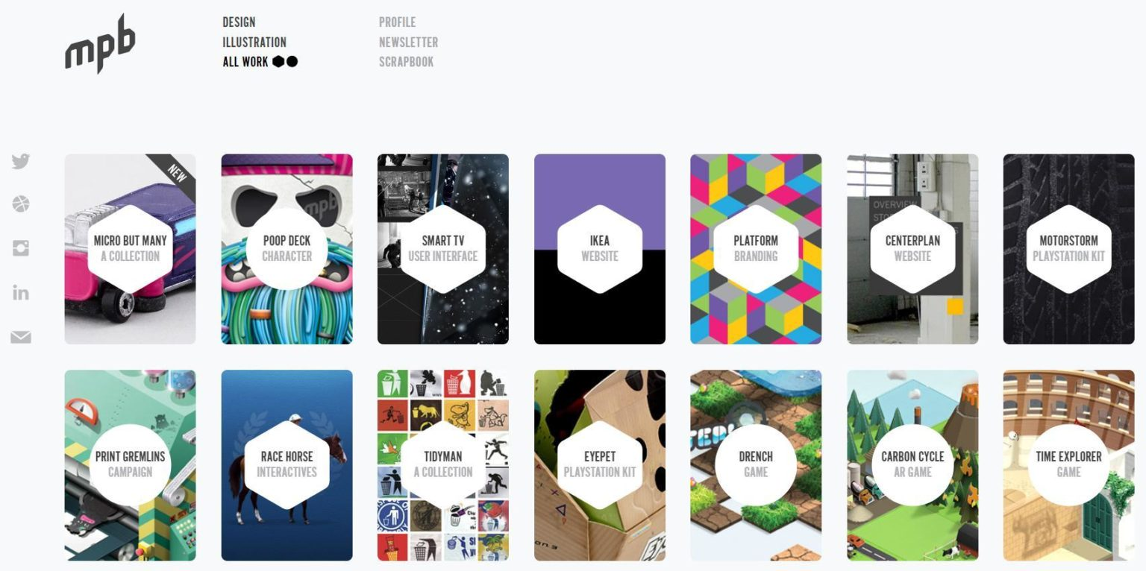

Fig: 1.1 showcase of our work

**Your About Page**

Your about page lets your potential clients see who is behind the work, get a glance of who you are, and if they would like working with you. You might ask, where do I start? Start with the most essential – with yourself. To make it easier, here is the checklist of crucial about page elements:

**Your name**

It sounds obvious but so many portfolios don’t have it. What if your potential client wants to do research about you, LinkedIn for example? Hi, I am Matt… is a great start to continue a story about yourself.

**Picture of You**

A picture gives a more personal touch. A portrait of you or a nice shot of you working on a new design. It’s the most original way to give visitors a sense of who you are. Make it simple but inviting.

#### Information About Yourself

#### Show your personality by telling a story about your professional and personal experience. Your education, what you have learned to do, projects you loved working with, awards, and recognition. Use this page to show your skills, the way you think and what are your passions. Make it brief, pleasant and memorable.

#### Below is an “About” page example from an Art Director, Marcin Dmoch. He presents himself using bright color design and little pieces of stories telling about his professional experience and best projects. He also has attached a downloadable CV for easy printing or resending the file to others. It’s a clean design containing all the key elements needed for an effective about page.

#### 

#### 

#### Case studies

#### Case studies or presentations are the best way of demonstrating the full scope of your projects. Each project should have its own story that shows the progress of the whole process, from beginning to the final outcome. Break down this creative process with lots of photos and notes revealing what’s behind each project.

#### This way your visitors can get a sense of what your projects are like, and how you moved from the initial planning phase to completion. Here are the components to include in your case study:

#### *Purpose of the project*: Why did you start the project.

#### *Objective*: What you accomplished.

#### *Approach:* How you accomplished it.

#### *Project duration:* How long it took you.

#### *Your role:* How you contributed to the team or project.

#### *Final product overview:* Pictures, videos, links, etc.

### **Testimonials**

Having some words from your clients can be very meaningful for those who just landed on your page. You can list your skills and tell how great you are but letting others say it can have a big influence. Reach out to your previous clients and ask for quotes that you can use on your website. People who enjoyed working with you will gladly praise your good work with a testimonial.

#### Call to Action(CTA)

#### A call to action compliments the purpose of your portfolio. To help you come up with a call to action for your site. What are the actions you want visitors to take? Your website should provide various ways clients can contact you. Be sure to include your business email address even if you use a contact form as some clients prefer it over forms.

#### 

#### Introduction

An online portfolio (may also be called a digital portfolio or e-portfolio) is an online representation of work you have created, as well as your skills and experiences. It could include your resume, a summary of qualifications and skills, images of class projects or design samples, audio and video, charts and schematics, process flows, and more. A portfolio website is a unique way to showcase your work and let others know about yourself. It’s like an evergreen platform for your project ,case studies, and information about you. In addition, its’s one of the best ways to express your personality, experience and capabilities.

Having your own website means customers are always able to find you and if interested reach out for you. If you don’t have an online presence nowadays, you are behind the times. A portfolio is a great way for Developers, photographers, Designers and wide range of artists to present their work online. It lets you reflect your identity through your works – photos, graphic design, sketches etc.

In a nutshell, you need a portfolio website to showcase your work. Whether you’re an individual or a small team of two or a company of ten people, it’s crucial that you have a unique online approach. A website portfolio will help you stand out from the crowd, show your uniqueness, build trust, and make sure that others can actually find you. The purpose of a portfolio is to help students to document their skills and achievements, challenge students to create their best work, and to help students to reflect on what they have accomplished . The Online Skills Portfolio is an online portfolio that allows students to display a wide variety of products, including documents, presentations, spreadsheets, photos and artwork. For each portfolio product, students write a brief description and complete a skills checklist which helps students to reflect on each item.

A student portfolio is a compilation of academic work and other forms of educational evidence assembled for the purpose of (1)evaluating coursework quality, learning progress, and academic achievement (2)determining whether student have met learning standards or other academic requirements for course, grade-level promotion and graduation.(4)creating a lasting archive of academic work products, accomplishments and other documentation. Advocates of students portfolios argue that compiling, reviewing and evaluating student work over time can provide a deeper and more accurate picture of what students have learned and are able to do than more traditional measures such as- standardized tests, quizzes or final exams that only measure what students know at a specific point in time.

Portfolios come in may forms, from notebooks filled with documents, notes, and graphics to online digital archives and student-created websites and they may be used at the elementary, middle and high school levels. Portfolios can be a physical collection of students work that includes materials such as written assignment, including awards, honours, certifications, recommendations, written evaluations by teachers of peers, and self-reflections written by students. Portfolios may also be digital archives, presentations, blogs, or websites that feature the same materials as physical portfolios, but that may also include content such as student-created videos, multimedia presentation, spreadsheets, websites, photographs or other digital artifacts of learning .

Online portfolios are often called digital portfolios or e-portfolios among other terms. In some cases, blogs or online journals may be maintained by students and include ongoing reflections about learning activities, progress and accomplishments. Portfolios may also be presented publicly or privately- to parents, teachers and community members as a part of a demonstration of learning, exhibition or capstone project .

It’s important to note that are many different types of portfolios in education and each form has its own purpose. For example, ”capstone” portfolios would feature student work completed as part of long term projects or final assessments typically undertaken at the culmination of a middle school or high school , or at the end of a long-term , possibly multiyear project. Some portfolios are only intended to evaluate learning progress are achievement in a specific course, while others are maintained for the entire time a student is enrolled in a school. And some portfolios are used to assess learning in a specific subject area , while others evaluate the acquisition of skills that students can apply in all subject areas .The following arguments are often made by educators who advocate for the use of portfolios in the classroom.

Student portfolios are most effective when they are used to evaluate student learning progress and achievement .When portfolios are used to document and evaluate the  knowledge, skills, and work habits students acquire in school, teachers can use them to adapt instructional strategies when evidence shows that students either are or are not learning what they were taught. Advocates typically contend that portfolios should be integrated into and inform the instructional process, and students should incrementally build out portfolios on an ongoing basis—i.e., portfolios should not merely be an idle archive of work products that’s only reviewed at the end of a course or school year.

Portfolios can help teachers monitor and evaluate learning progress over time**.** Tests and quizzes give teachers information about what students know at a particular point in time, but portfolios can document how students have grown, matured, and improved as learners over the course of a project, school year, or multiple years. For this reason, some educators argue that portfolios should not just be compilations of a student’s best work, but rather they should include evidence and work products that demonstrate how students improved over time. For example, multiple versions of an essay can show how students revised and improved their work based on feedback from the teachers or their peers

Portfolios help teachers determine whether students can apply what they have learned to new problems and different subject areas**.**A test can help teachers determine, for example, whether students have learned a specific mathematical skill. But can those students also apply that skill to a complex problem in economics, geography, civics, or history? Can they use it to conduct a statistical analysis of a large data set in a spreadsheet? Or can they use it to develop a better plan for a hypothetical business. (Educators may call this ability to apply skills and knowledge to novel problems and different domains “[transfer of learning](http://edutechwiki.unige.ch/en/Transfer_of_learning)”).

**System Required**

|  |  |
| --- | --- |
| Operating  System | Windows7/Windows 8/Windows 10 |
| Ram | Minimum-2GB  Recommended-4GB |
| Disk Space | At least 4GB free disk space is Required for smooth performance. |
| IDE | Visual studio Code |

**Advantages of a Portfolio Website**

* Evaluating coursework quality, learning progress, and academic achievement.
* Professional Way to Showcase Your Work.
* Shows You're More Than Just a Resume.
* It's A Great First Impression for Employers.
* Increases Your Visibility and Online Presence.
* Student portfolios are most effective when they are used to evaluate student learning progress and achievement.
* Portfolios can encourage students to take more ownership and responsibility over the learning process.
* Assists in planning for the future.
* Encourage better attention to the learning process.
* You can fully customize your site to reflect your creativity, uniqueness, and skills. This is especially important for web designers and web developers.
* It makes you seem more professional, just like having your own custom e-mail does.

**-: Disadvantage of a Portfolio Website :-**

* Portfolio Assessment's Inherent Limitations.
* Lack of Standardization.
* Not Feasible for Large Scale Learning Assessment. ...
* Bias
* The creation of digital portfolios requires advanced knowledge and skills and sometimes expensive, high-tech equipment.
* Viewing a digital portfolio sometimes requires special software as well as additional knowledge and skills on the part of the viewer.
* Be aware of the possibility of plagiarism as it may be easier to use your information as it is already in a digital format and easily copied and pasted or saved onto another person’s computer.
* You have to maintain it, fix all the issues that might be popping out from time to time, and keep it up–to–date on the technical side,
* Making big changes to the site might be more complicated than you think.
* You also have to consider SEO. Bad SEO will make you hard to find, so you have to work on it.
* You have to pay fees for hosting and domain. You might also need to pay the professionals to fix bugs or make adjustments.

**Flowchart**

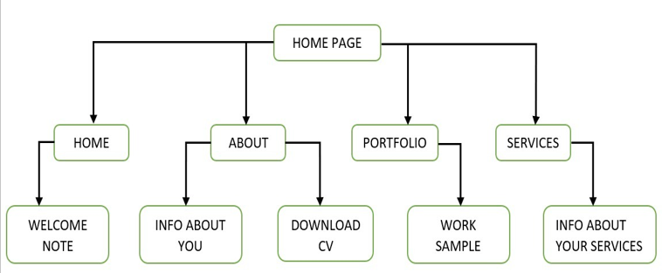

**Snapshots**

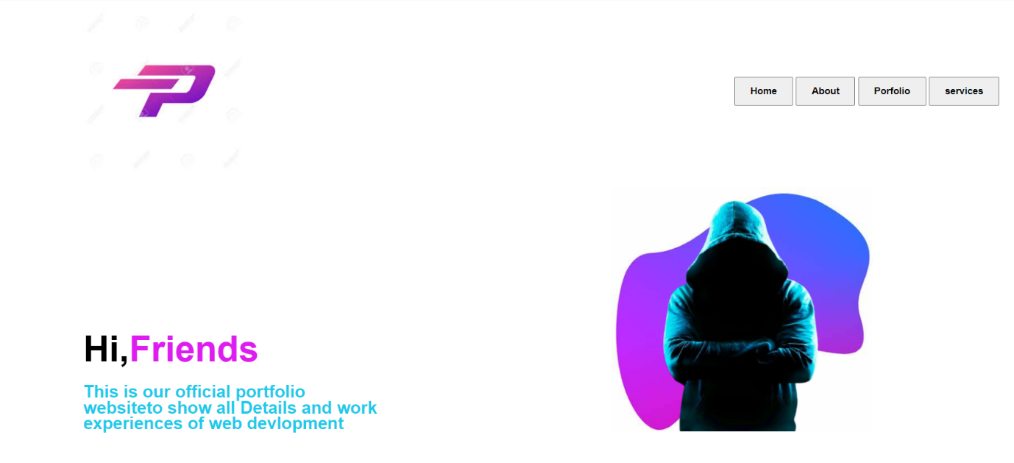

Fig: 1.1 showcase of our work

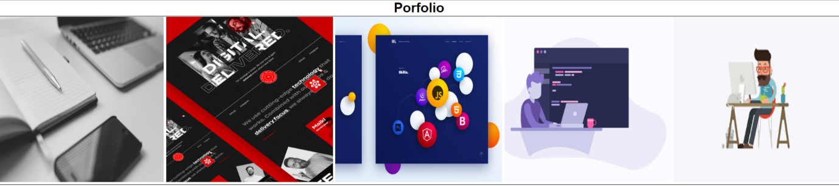

Fig: 1.1 showcase of our work

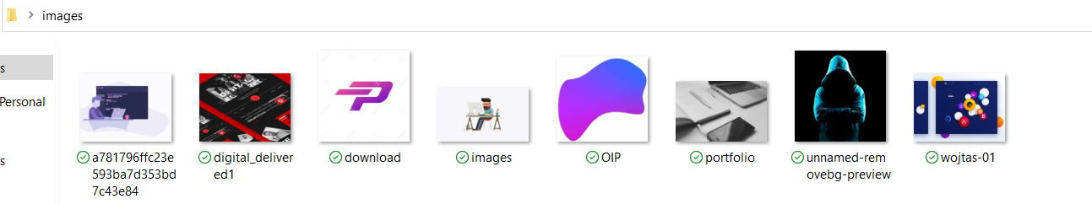

Fig: 1.1 showcase of our work

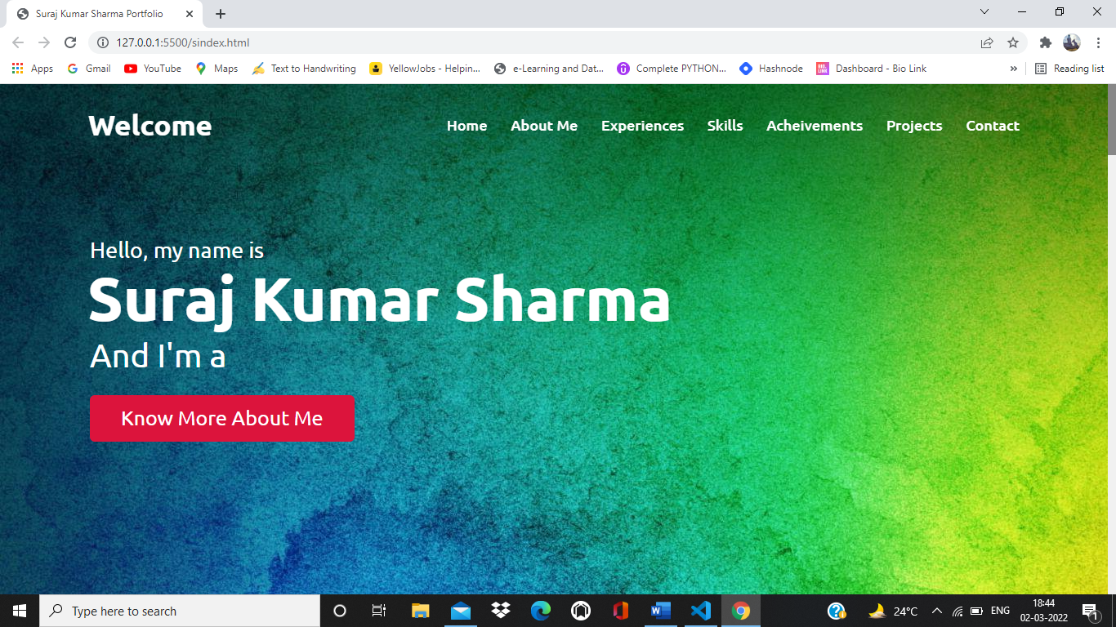

Fig: 1.1 showcase of our work

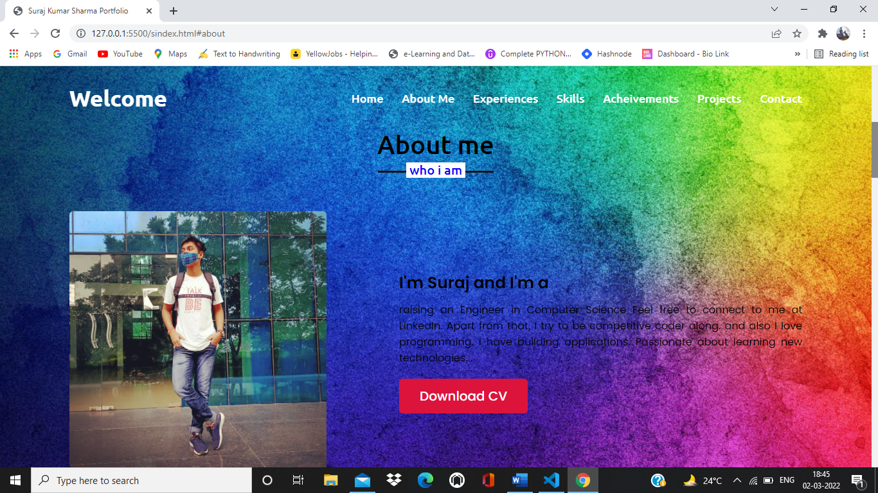

Fig: 1.1 showcase of our work

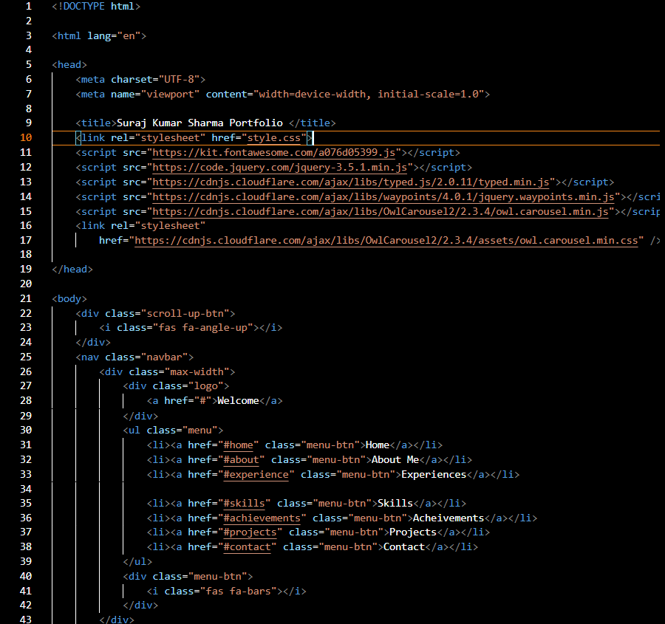

Fig: 1.1 showcase of our work

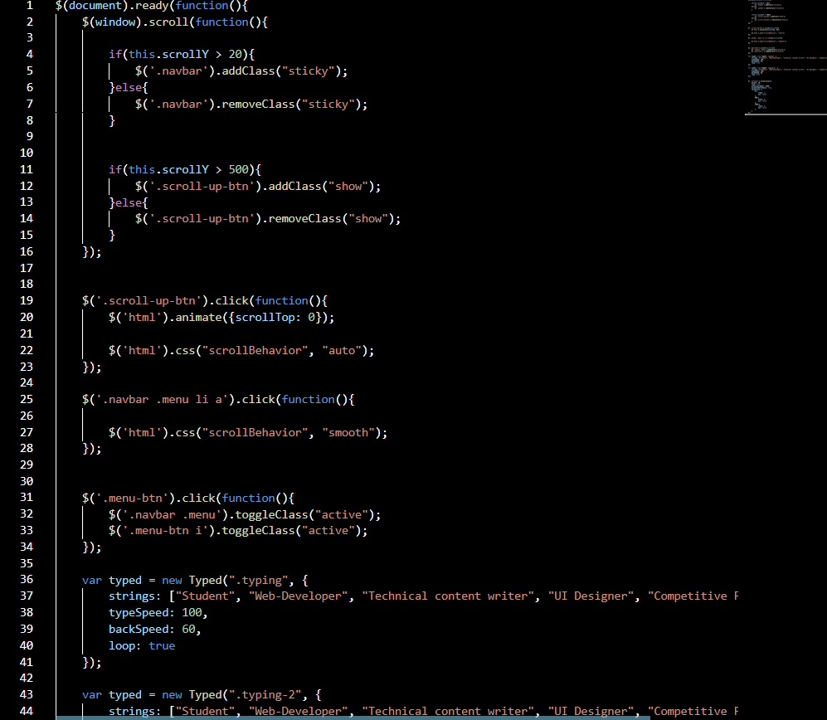

Fig: 1.1 showcase of our work

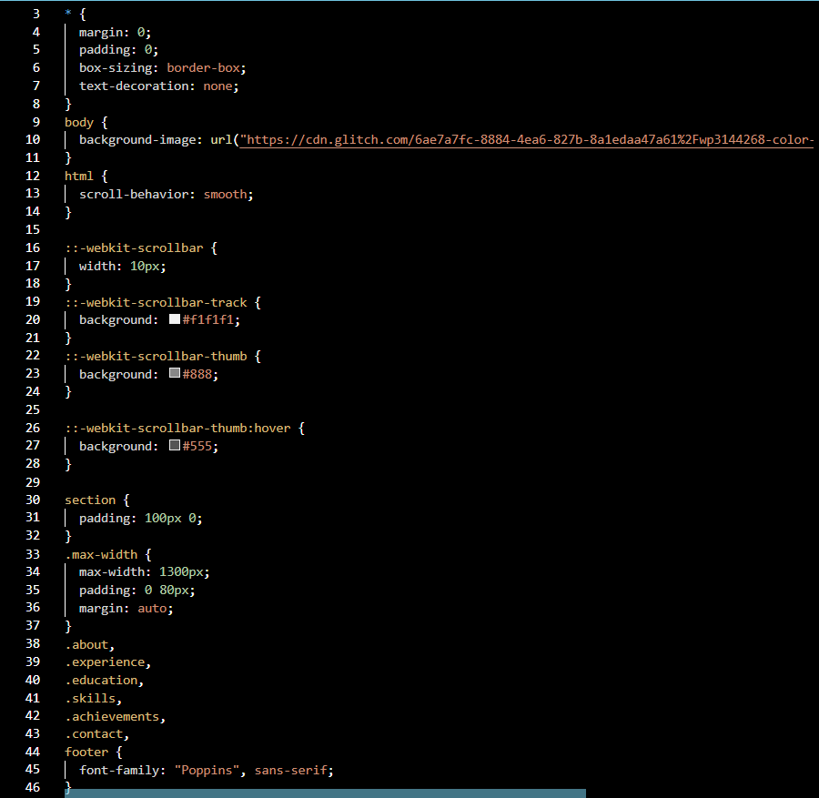

Fig: 1.1 showcase of our work

**Conclusion**

Throughout this portfolio you can see that my work was a progress from the rough draft to polished draft . All of the work I composed onto this file was the journey . This website is simple to understand and no any specific system required to operate it . Portfolio website is a good platform to showcase your work and an easy way to be get hired . In addition to showcase the students work, portfolio emphasis upon three domains, affective, cognitive, psychomotor and encourage students to become active participant in understanding their own learning. Portfolios can help teachers monitor and evaluate learning progress over time. The purpose of portfolio is to document all stage of learning process. helping students reflect on their academic goal and progress as learners. It allows students to be more personal and creative in order to expand on and exhibit skills, knowledge and experience. The personal information that you compile in to your portfolio can greatly reflect on students ability as an individual. Examine and cut processes regularly. This is necessary to counteract process growth without you taking any action. It is often easier to add a new process than to cut an existing one, but both are necessary to keep the portfolio process in balance and to avoid bloat. Requests to add new processes will come naturally if the process is visible, people are engaged, and the function is working well. Opportunities to cut or remove portions of the process are just as important but may not emerge as frequently through the process, so make sure time is spent focusing on things to cut in addition to things to add. Keep everything as simple as it can be. Track everything that is consuming resources, and go beyond formal projects to anything that is a meaningful piece of work or use of resources.

-**:Future Scope :-**

**-: References :-**